**(20) Air mass & Front**

1. AIR MASS

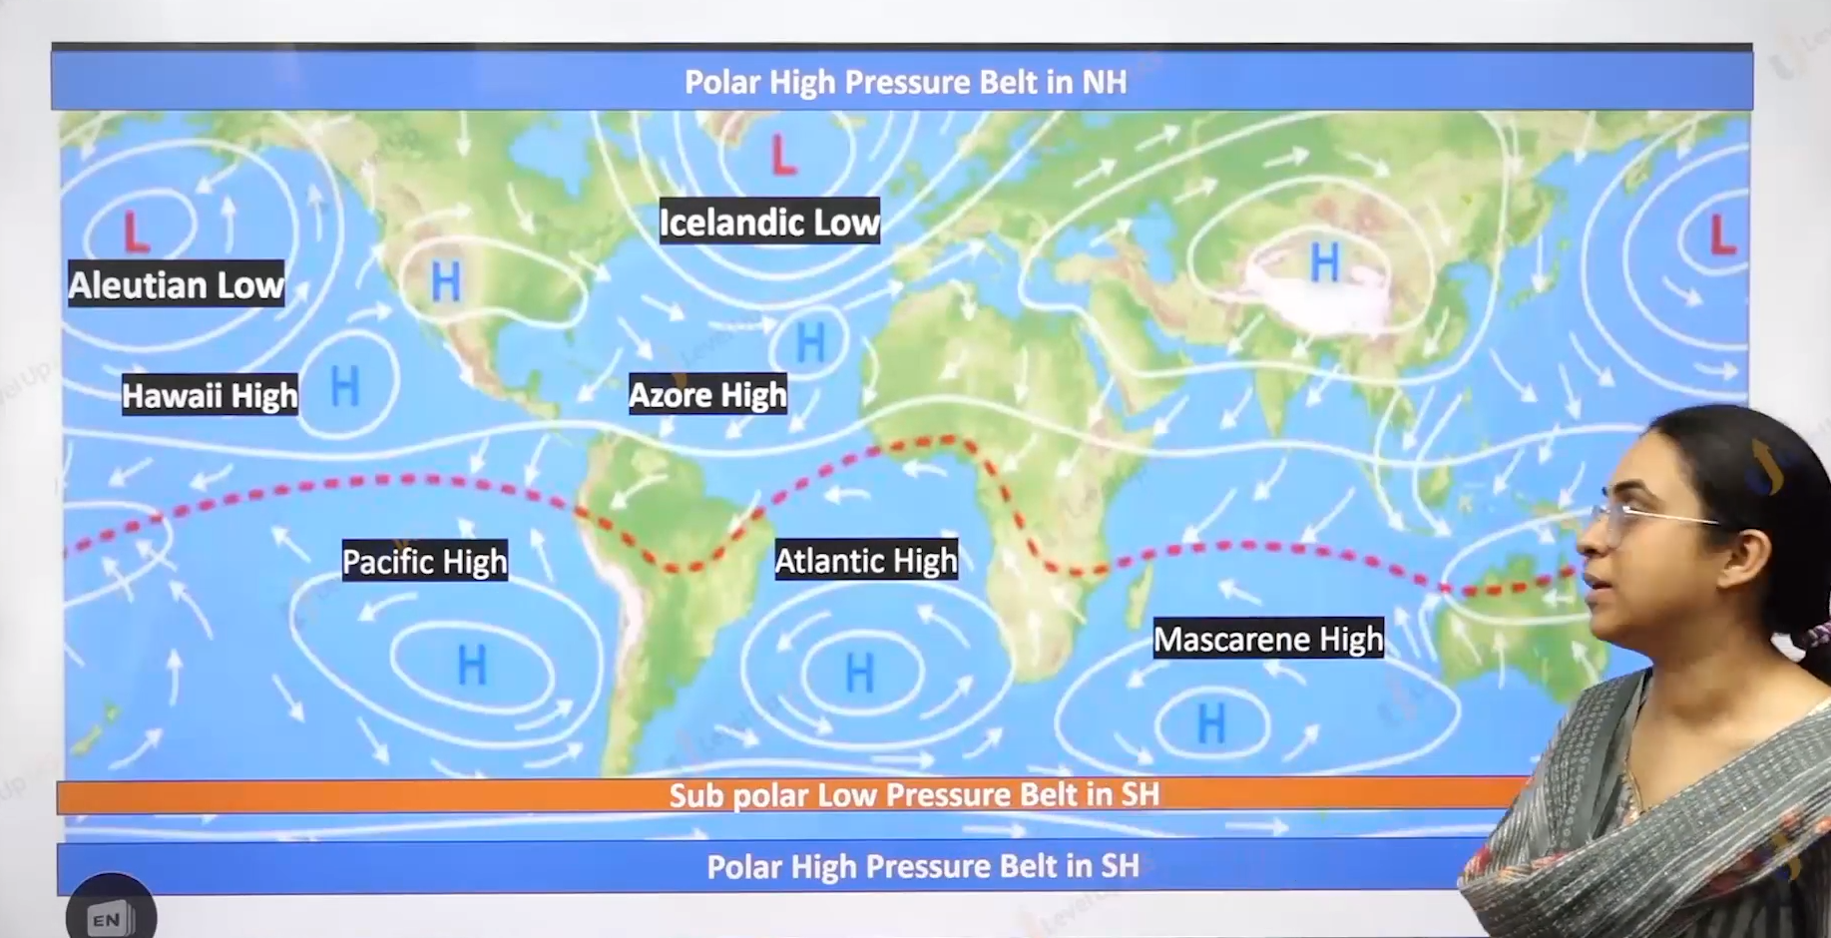

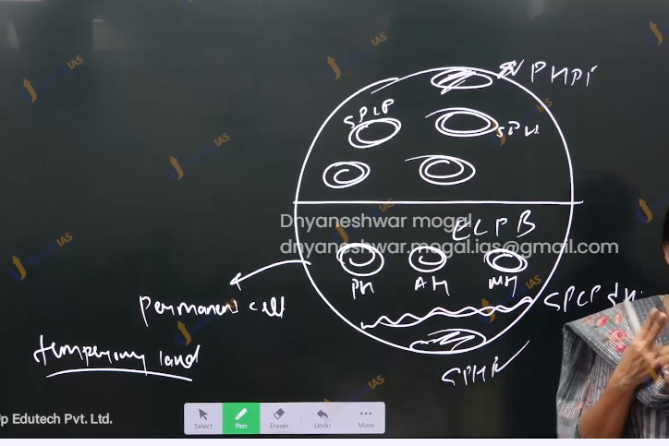

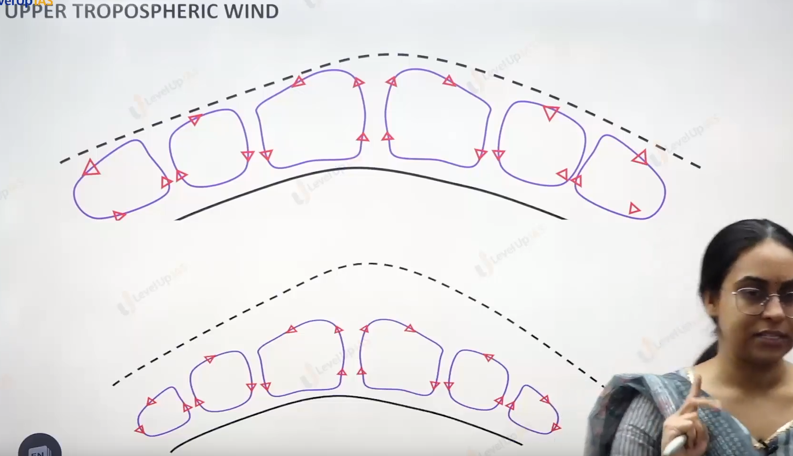

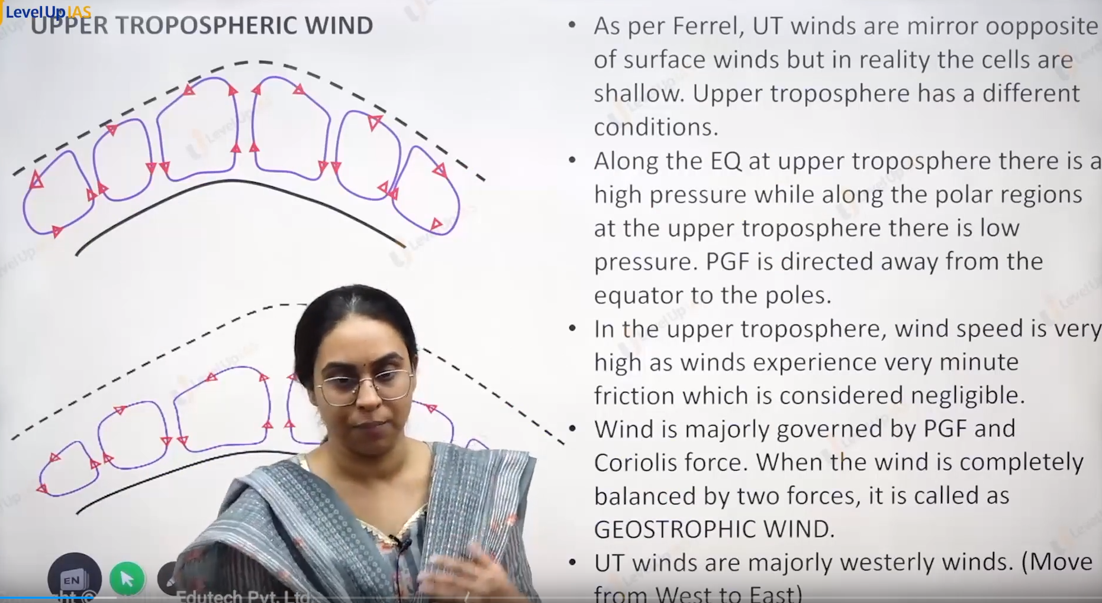

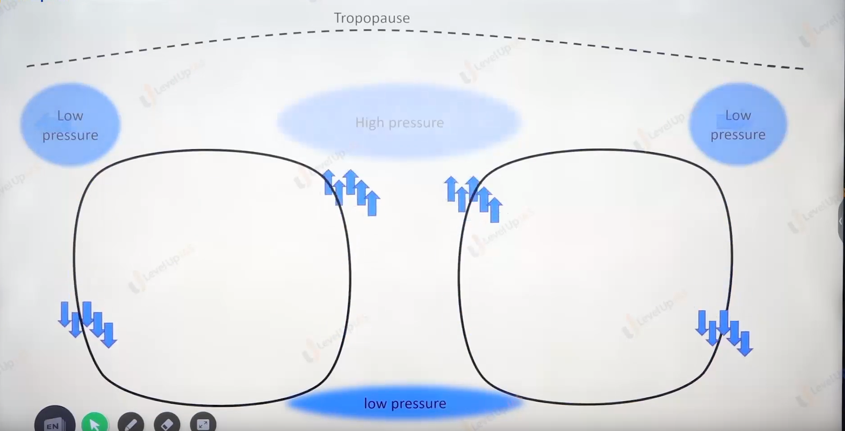

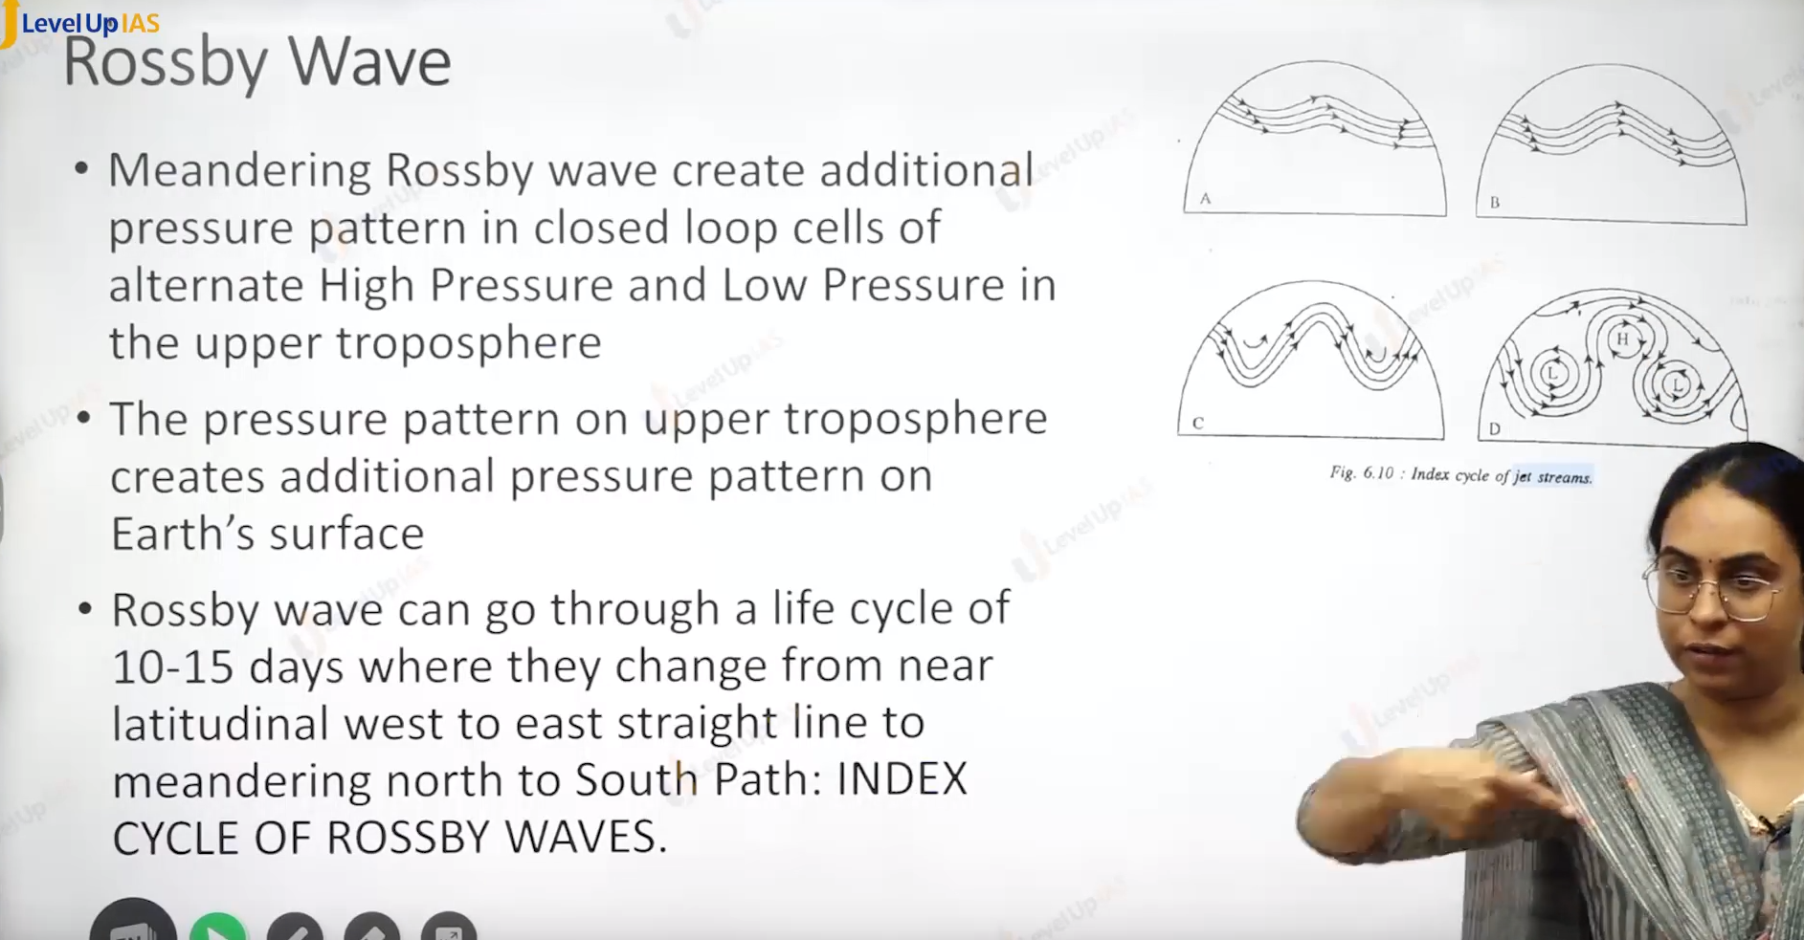

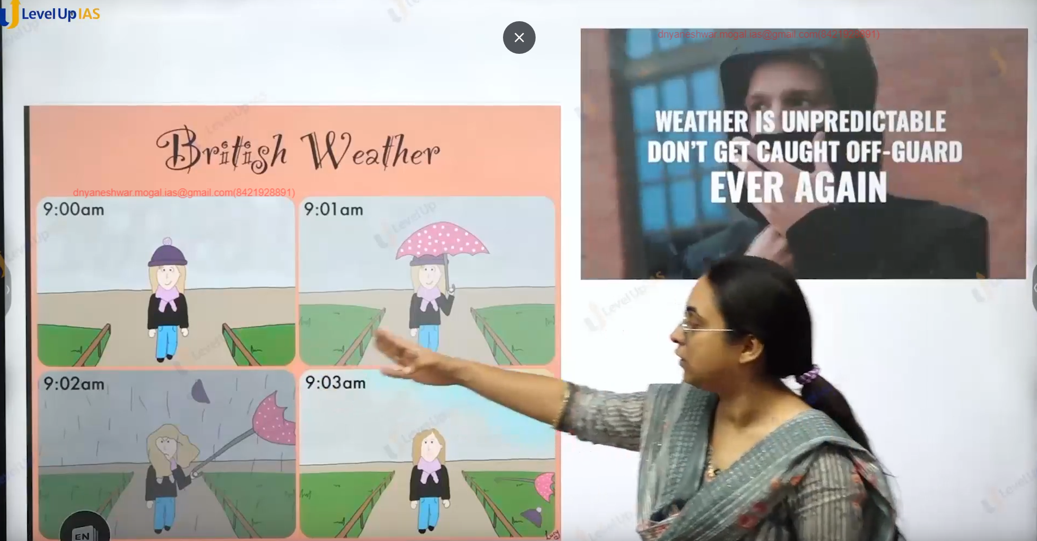



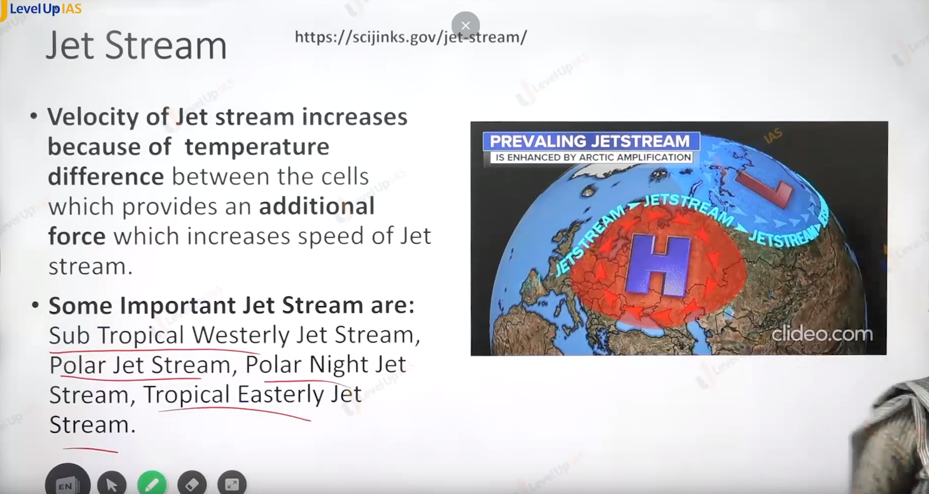

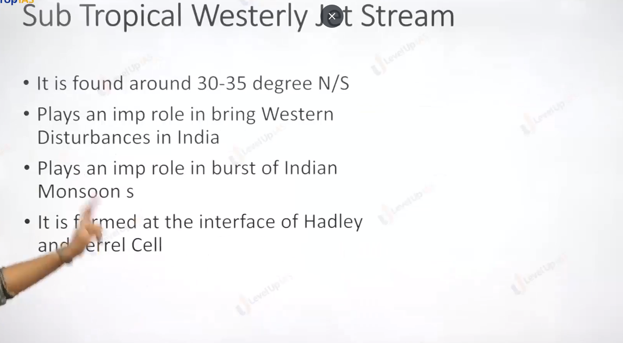

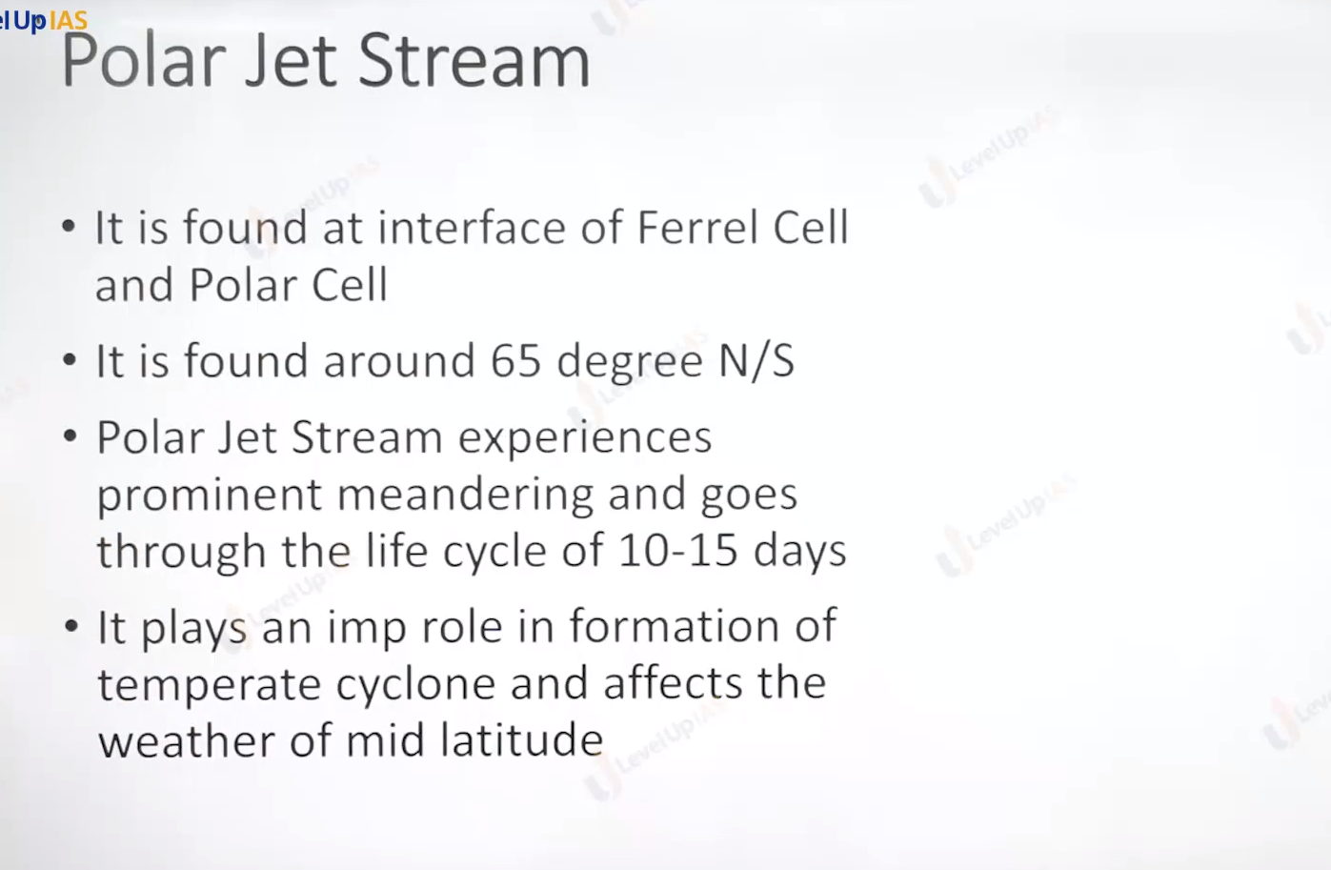

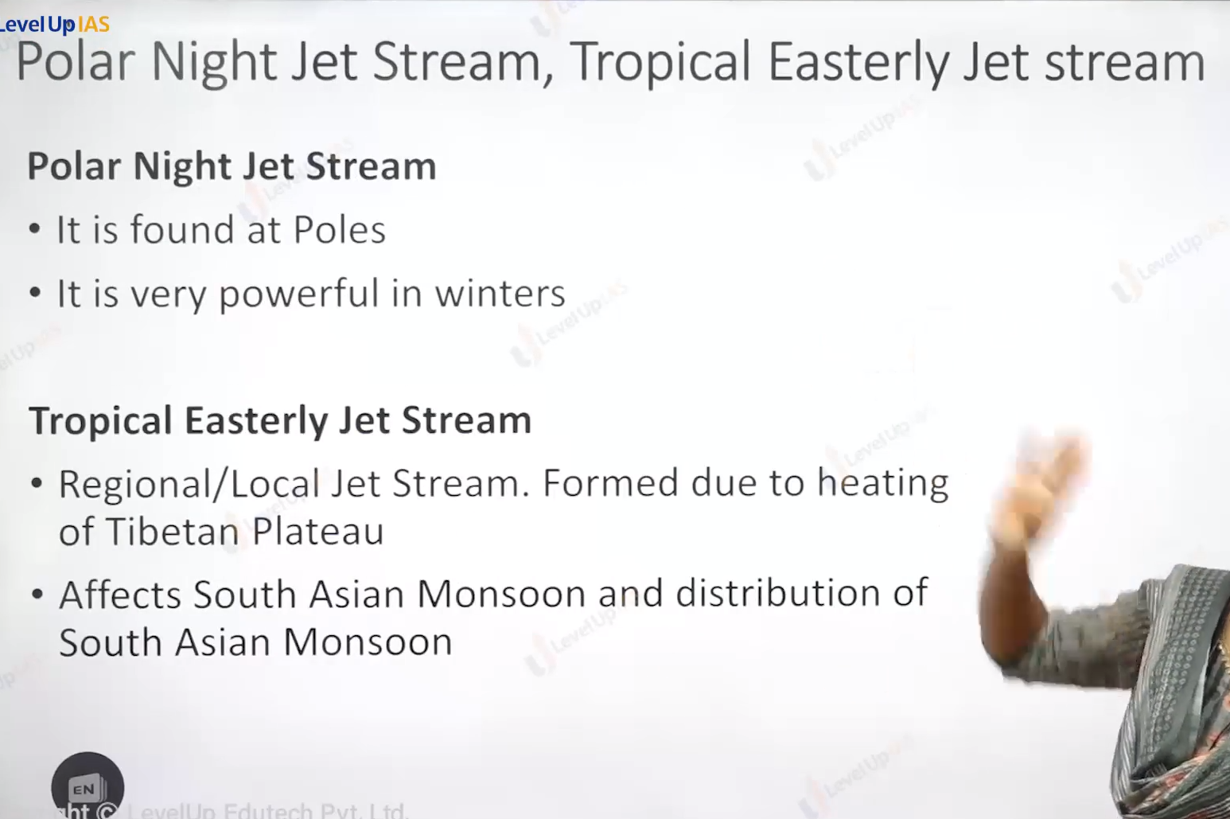

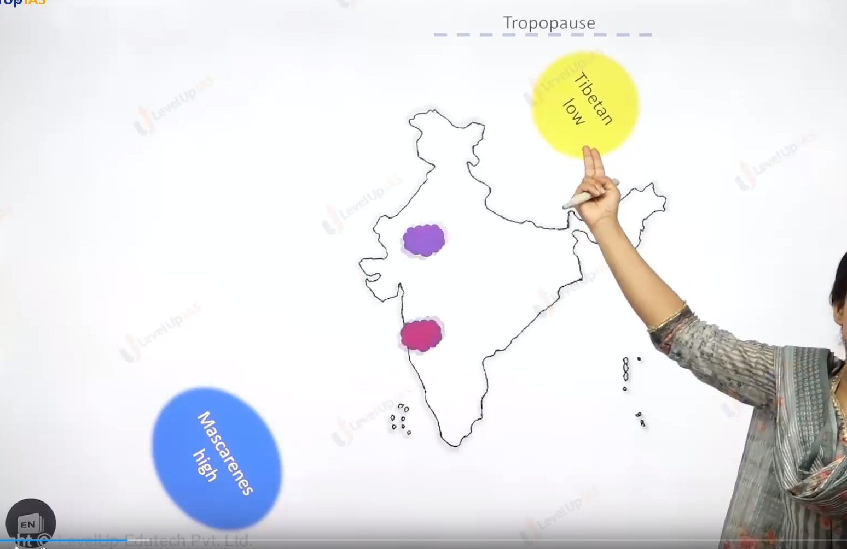

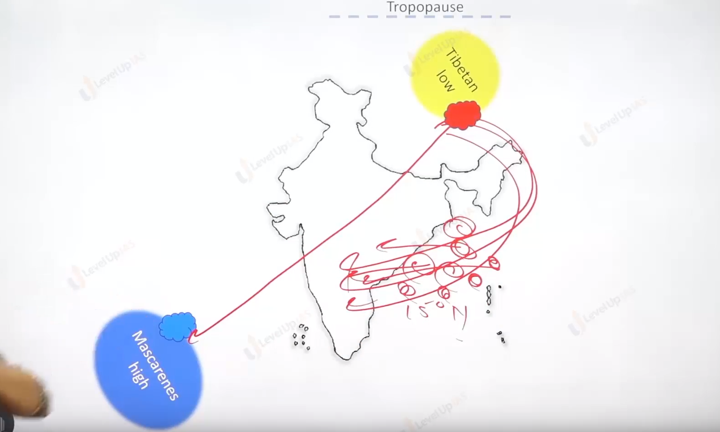

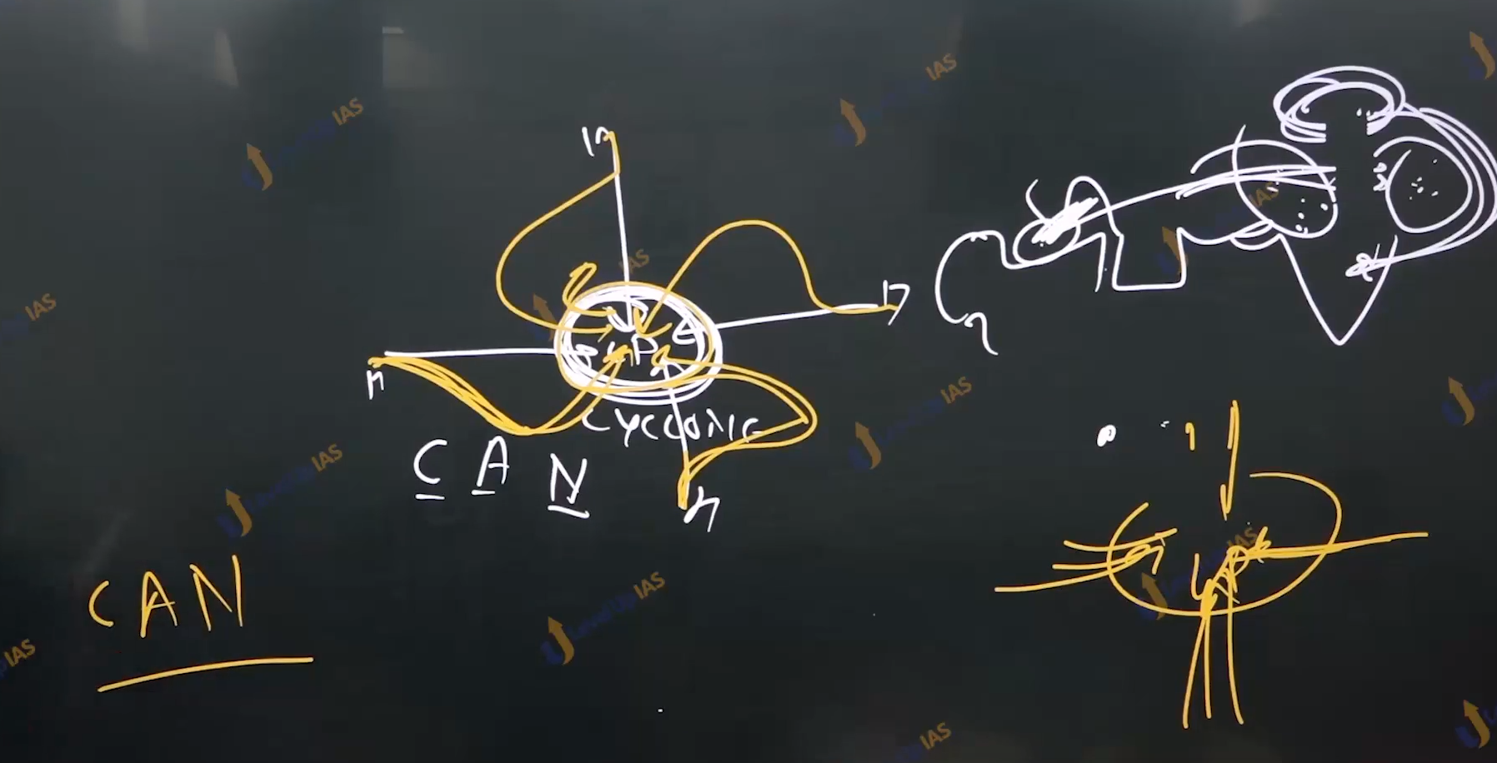

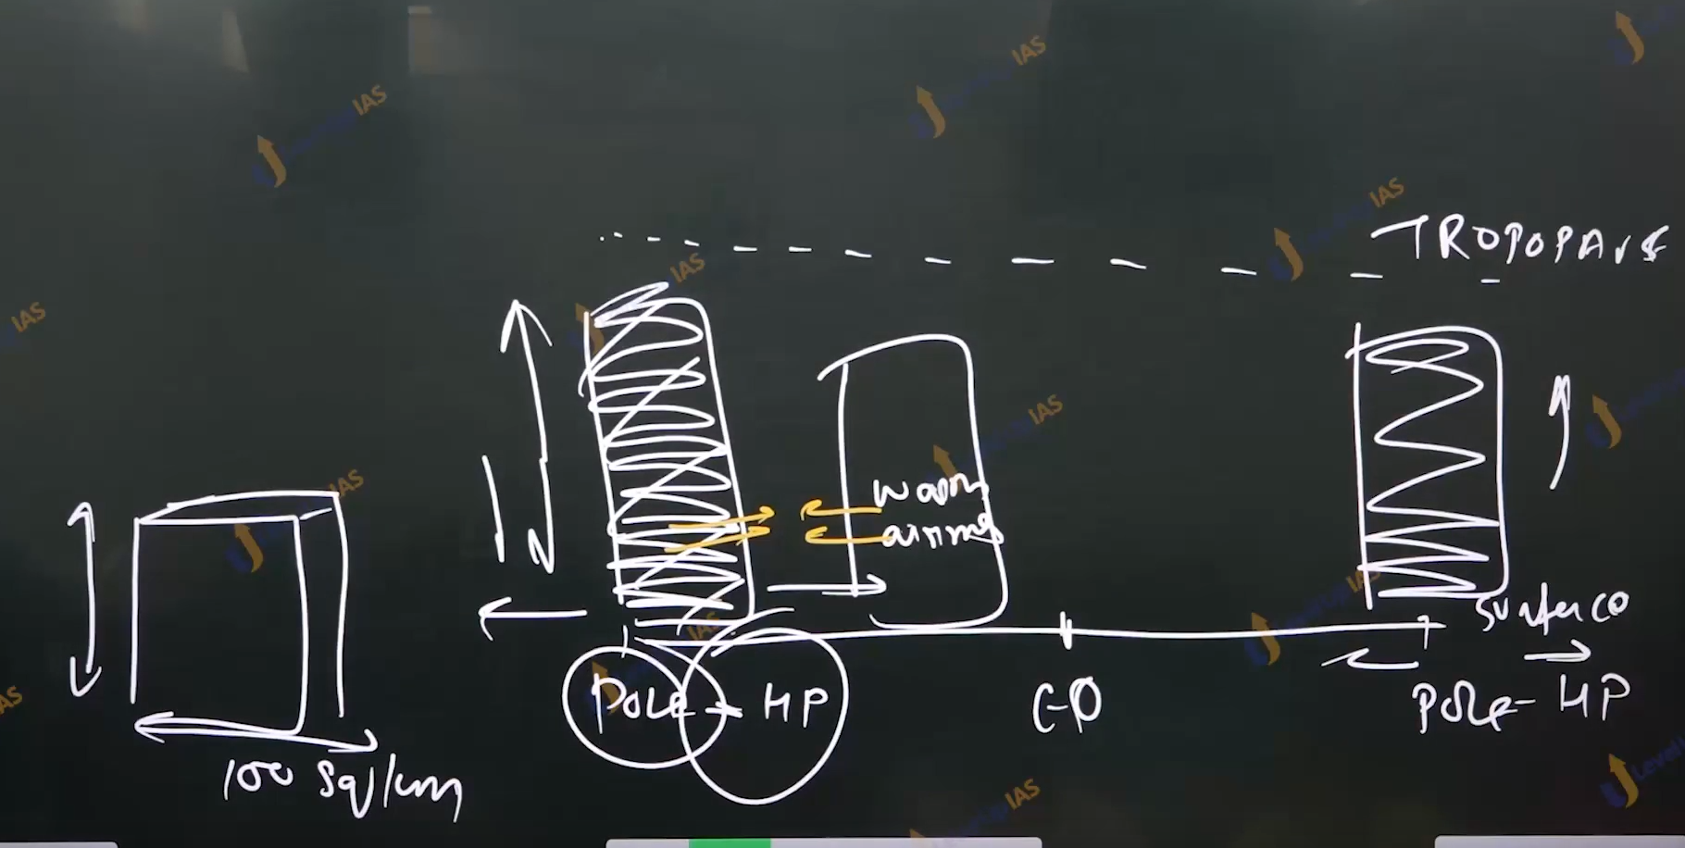

Cyclone:

1. To understand the temperate cyclone, it is important to understand the concept of air mass.
2. Air mass are massive bodies of air covering 1000 sqkm (horizontally on earth’s surface and they extents up to trope pause.)
3. Air masses have nearly same temperature and moisture level horizontally the nature and properties of air mass are acquired from the surfaces over which air mass developed.
4. Air masses formed over relatively flat surfaces and extensive surfaces
5. Air mass develops in the high-pressure conditions as these conditions prevent from air moving ex. Siberian high pressure conditions in winters and Canadian high-pressure conditions.
6. The places for the formation of air mass are polar regions, artic Antarctic, and tropical region.
7. Based on place of formation there are 4 types of air mass.
   1. Antarctic: this air masses are found in the Antarctic and very cold
   2. Artic air mass: they are formed in the artic region, and they are cold.
   3. Tropical air mass: these air masses formed int the lower laying region and they are comparatively warm.
   4. Polar: these air masses form high latitude region, and they are cold.
8. Based on the nature of surface there can be 2 types of air mass.
   1. Maritime: they are founded over the water bodies and filed with moisture
   2. Continental air mass: these are formed over land and therefore they are dry.
9. according 6 type of air mass identified
   1. continental artic.
   2. Continental Antarctic
   3. Continental polar Siberian air mass
   4. Continental tropic ex Sahar
   5. Maritime tropic ex along Gulf of Mexico
   6. Maritime polar : ex Continental air mass when crosses the and reaches the ocean it becomes maritime polar.

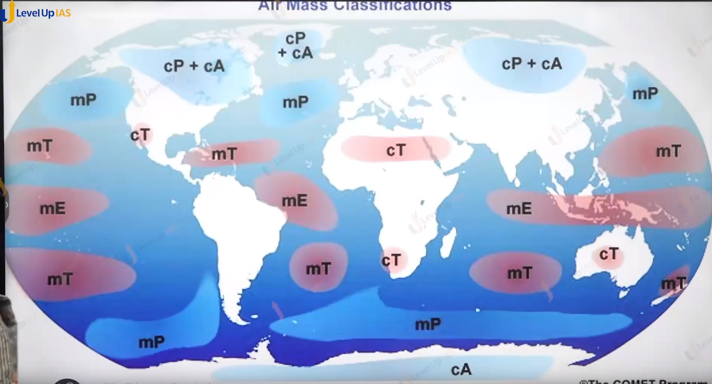

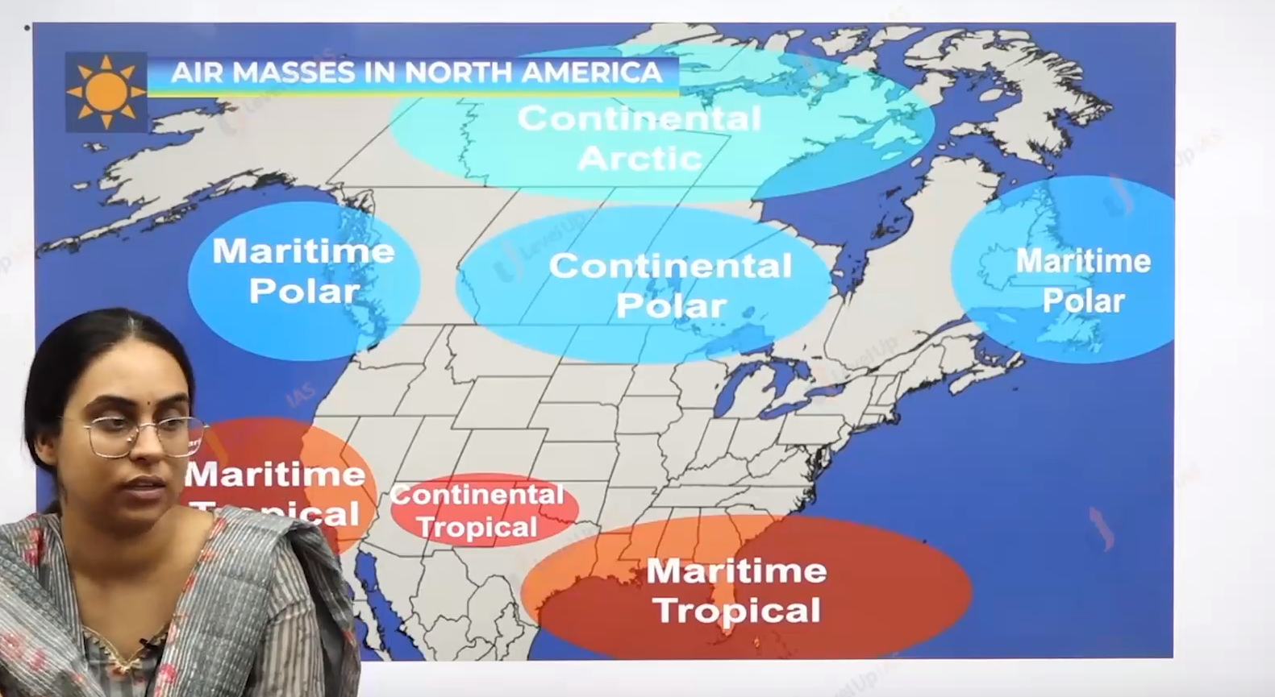

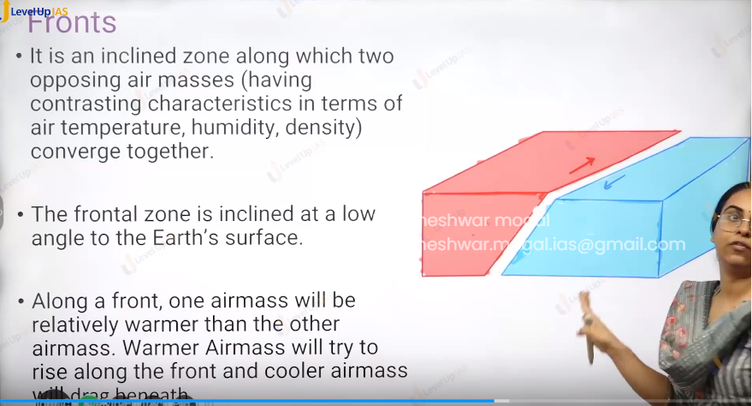

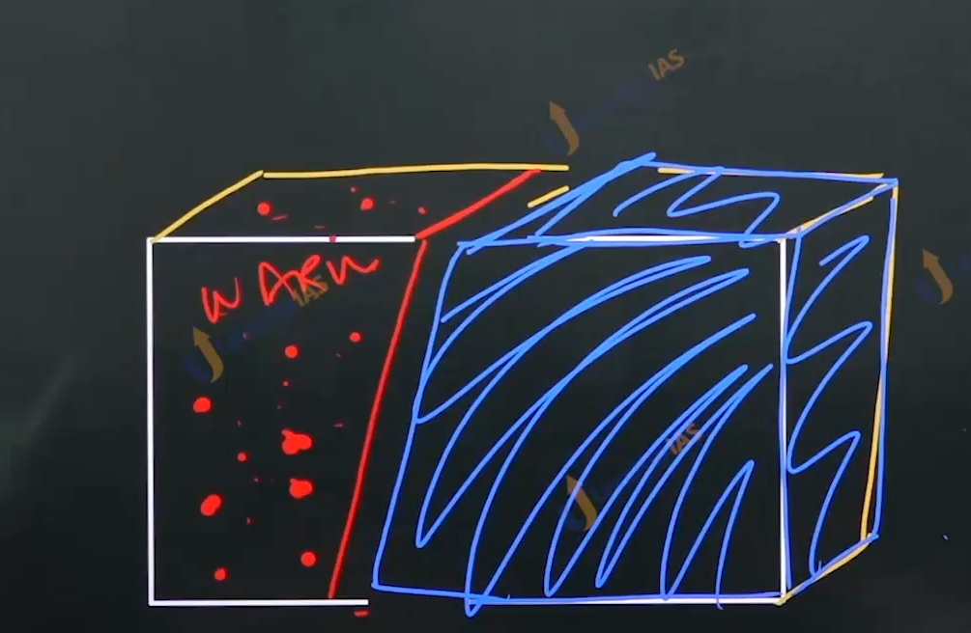

Fronts:

1. It refers to the incline zone two opposing (having contrasted the temperature, density, humidity) converge together.
2. The frontal zone Is inclined at the low angle to the surface along the front one air mass will be relatively warmer than the other.
3. Warner air mass will try to rise along the front and the cooler air mass will drag beneath the front.

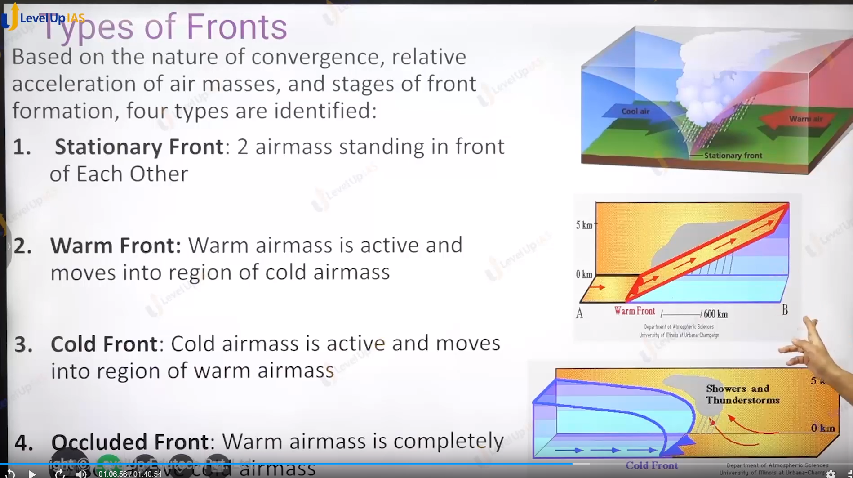

Type of fronts:

1. Based on the nature of conversion and relative acceleration of the air masses and the stages of front formation 4 type of fronts are identified.
   1. Stationary fronts: two air masses are standing in front of each other.
   2. Warm front: warm air mass is active and moved into the region of cold air mass.
   3. Cold front:
      1. Cold air mass is active and moved into the region of warm air mass.
      2. Cloud with very high vertical extents columbiums air cloud.
      3. Columbiums cloud formed along the cold front
   4. Occluded front: Warm air mass completely tossed above the cold air mass

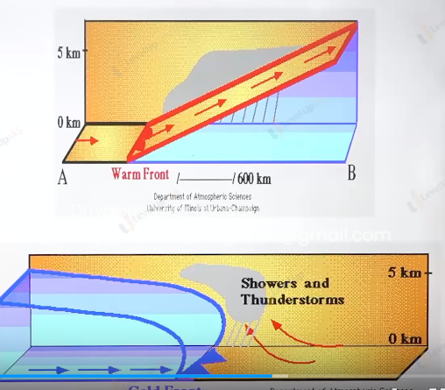

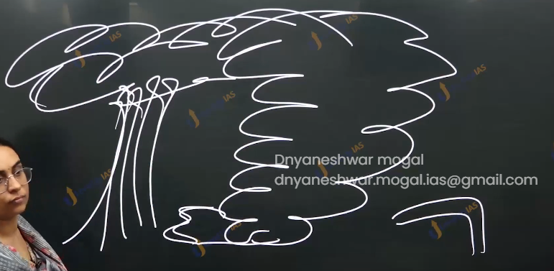

(columbiums cloud)

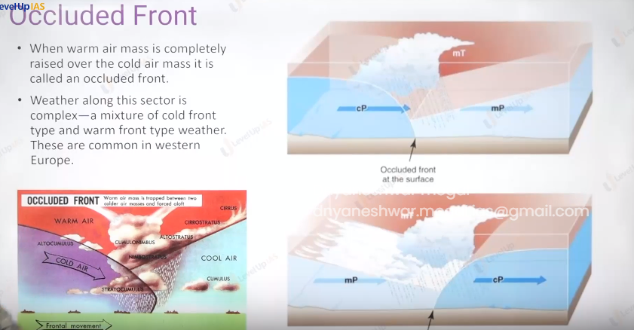

Nature of fronts:

1. The cold front is relatively steeper and warmer front relatively gentle.
2. Cold air mass moves faster as compared to warm air mass.
3. Warm air mass raises above and cold air mass always pusses from the below whether in the warms front or cold front.

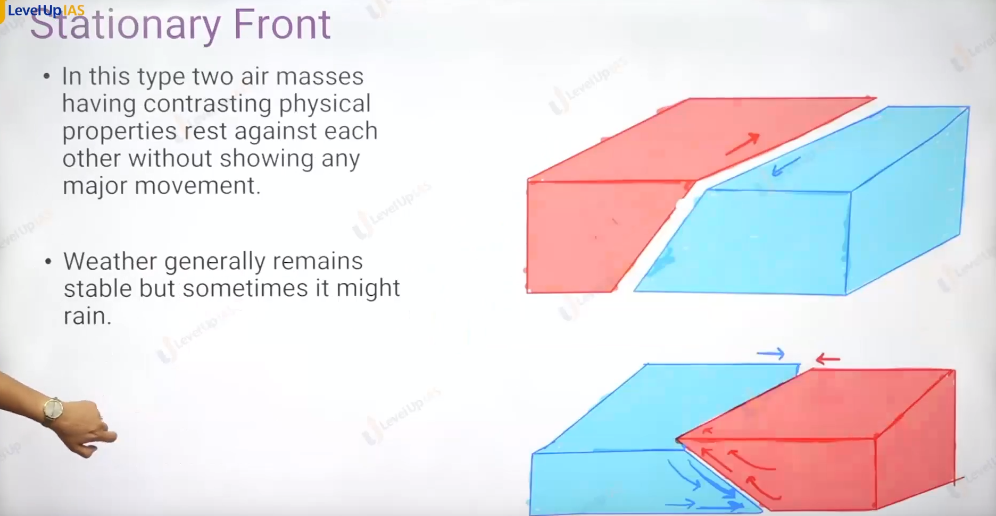

Stationary front:

1. Warm air mass and cold air mass lays side by side without showing any major movement
2. The weather generally remains stable without any precipitation.

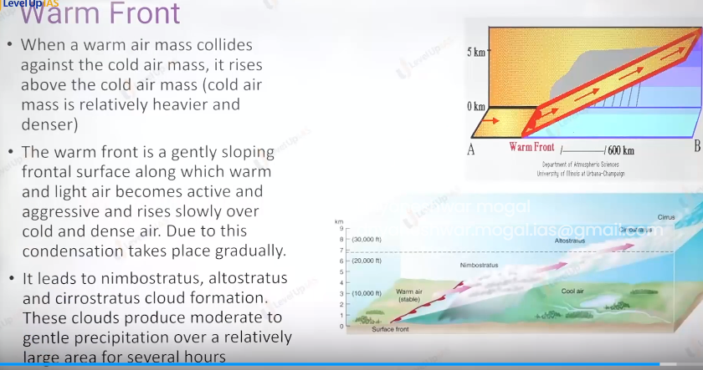

Warm Front:

1. When the warm air mass collies against the cold ai r mass, it raises above the cold air mass
2. A warm front is a gently sloping frontal surface along which warm and light air rises. Due to raising of warm air condensation take places.
3. It leads to formation of various cloud like nimbostratus altostratus , cirrostratus , cirrus.

